

_{LAB REPORT 10}

SUBMITTED TO: MR. MUBASHIR IQBAL
SUBMITTED BY: AHMED SALEEM RANA
_{REG ID: 24-CYS-023}
_{SECTION: B}

_{HITEC UNIVERSITY TAXILA, CANTT}
TASK 01

Predict Canada's per capita income in the year 2020 using the canada_per_capita_income.csv file. Using this, build a regression model and predict the per capita income of Canadian citizens in the year 2020. Here is the link to the CSV file: https://drive.google.com/file/d/1mhtt- 55J4kyZeIMY4EJpUV7ul3hXYEPw/view?usp=sharing
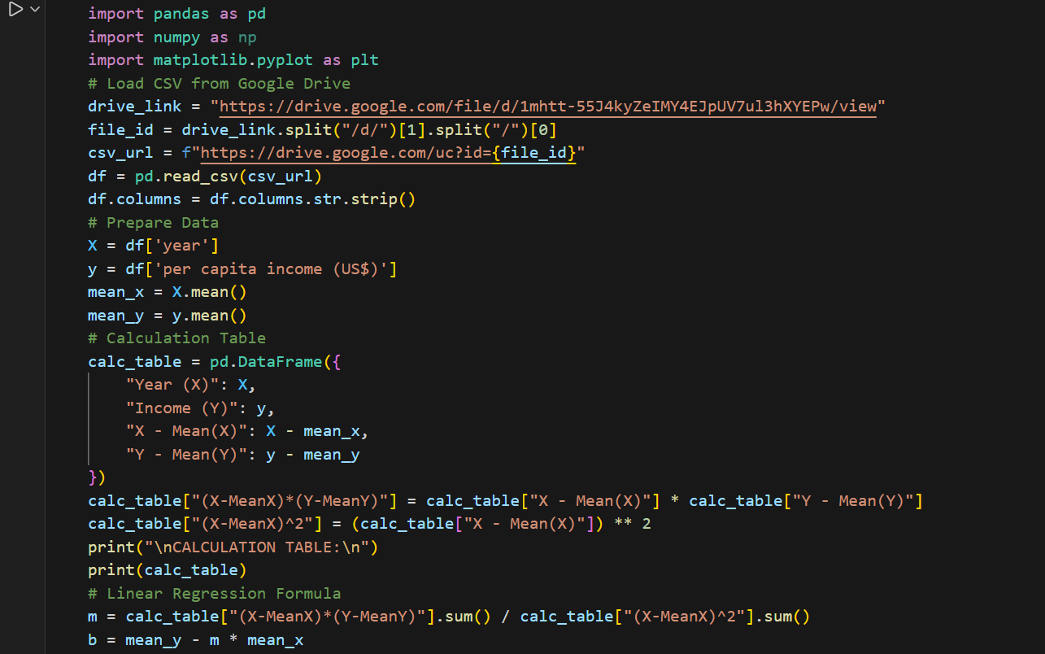
CODE:

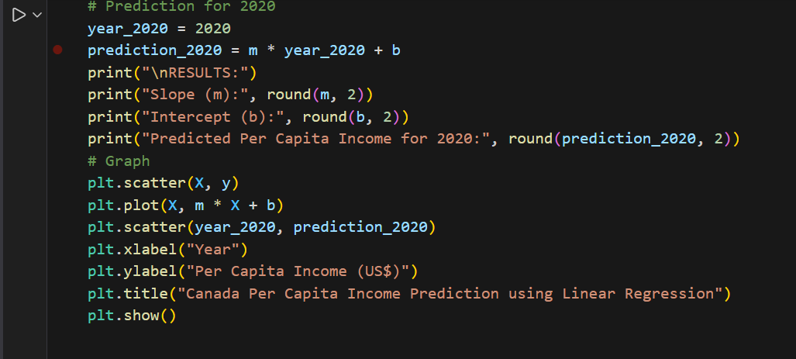
OUTPUT:
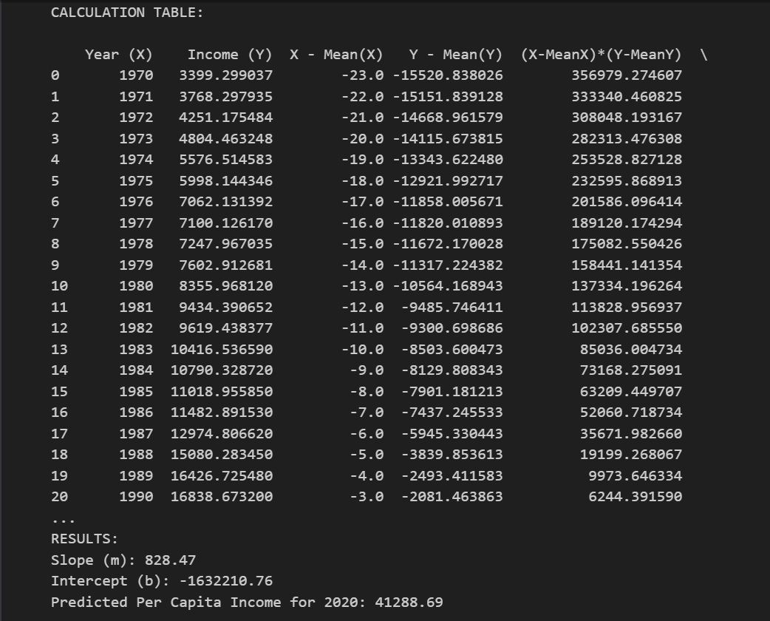
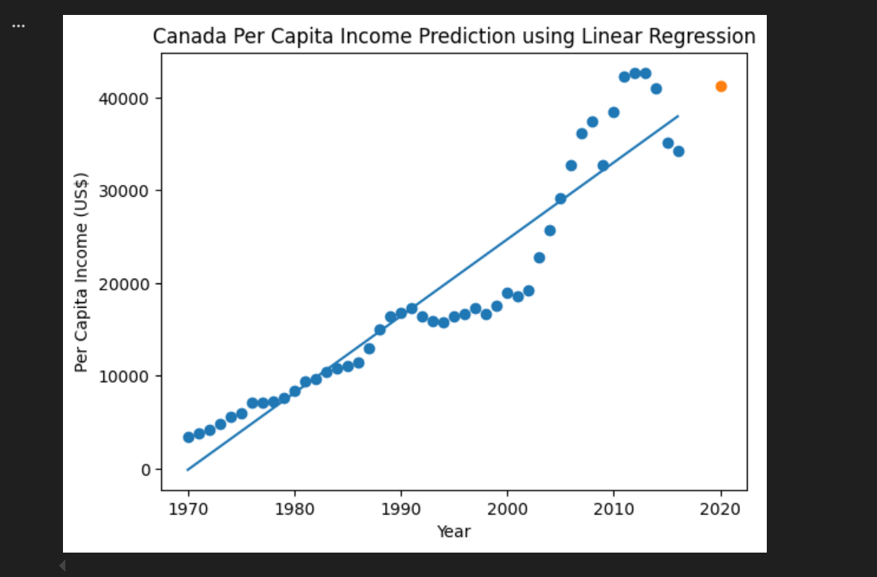

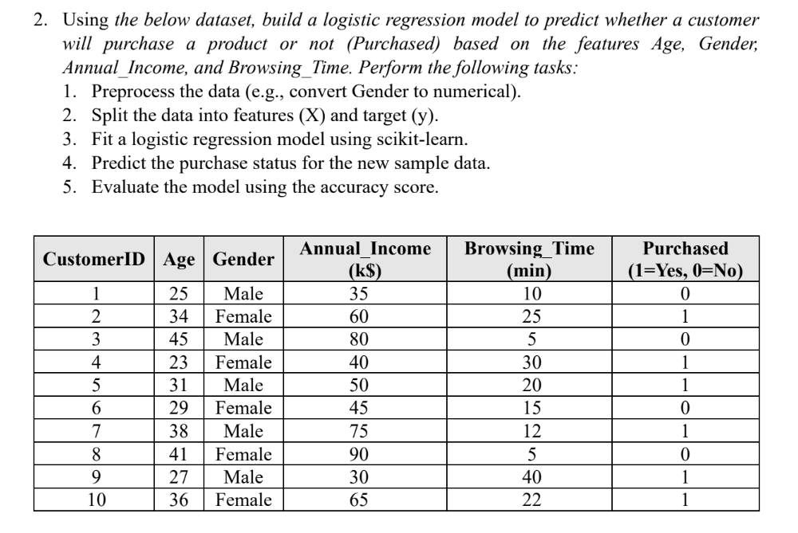
TASK 02
CODE:
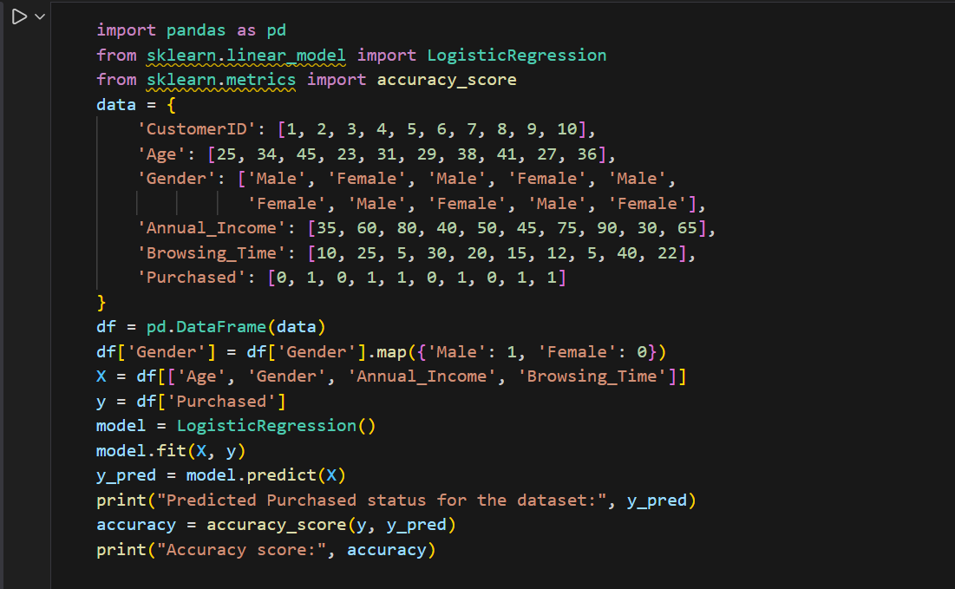
OUTPUT:

CONCLUSION:
First in these machine learning algorithms, we applied logistic regression, a binary classification algorithm, where we predicted if customers would make a purchase based on characteristics such as age, sex, annual income, as well as time spent browsing. However, after assigning a range of numeric values for sex, the algorithm produced 100% accuracy on a limited set of data. We also applied linear regression on forecasting the per capital income in Canada for the year 2020 based on previous data, after which we obtained a figure of between $40,000 and $45,000.

